H.T No
Regulations:
A14

Sreenidhi Institute of Science and Technology
(An Autonomous Institution)
Code No: 4B616 Date: 20-Oct-2021(AN)

B.Tech III-Year II- Semester External Examination, Sept/Oct - 2021 (Supplementary)
Principle of Finite Element Method (ME)

Time: 3 Hours Max.Marks:70

Note: a) No additional answer sheets will be provided.
b) All sub-parts of a question must be answered at one place only, otherwise it will not be valued.
c) Missing data can be assumed suitably.

ANSWER ANY 5 OUT OF 8 QUESTIONS. EACH QUESTION CARRIES 14 MARKS.

Bloom's Cognitive Levels of Learning (BCLL)

Remember | L1 | Apply | L3 | Evaluate | L5
Understand | L2 | Analyze | L4 | Create | L6

 |  |  | BCLL | CO(s) | Marks
1. |  | Calculate the displacement at the free end of a 50cm long tapered bar of area of cross section 1000 mm² at its fixed end and 600 mm² at the free end, subjected to an axial tensile load of 1kN at the free end. Assume E = 200GPa. | L5 | CO1 | [14M]
2. |  | For the two bar truss as shown in figure , determine the displacements of node 1 and the stress in element 1-3  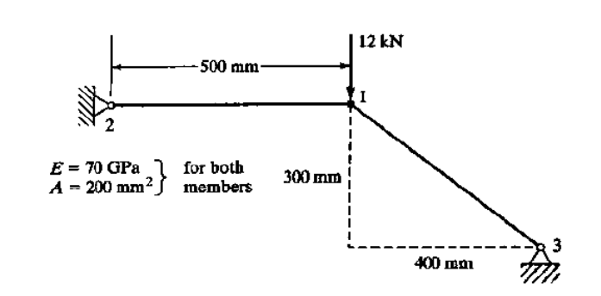 | L5 | CO2 | [14M]
3. |  | The nodal coordinates and the nodal displacements of a triangular element, under a specific load condition are given below. X_{I} = 0, Y_{I} = 0, X_{J} = I mm, Y_{j} = 3 mm, X_{k} = 4 mm, Y _{k} = I mm U_{I} = I mm, V_{I} = 0.5 mm, U_{J} =-0.05 mm, V_{J} = 1.5 mm, U_{k} = 2 mm, V_{k} =-1 mm . If E = 2 x 10⁵ N/mm² and Poisson ratio = 0.3, find the stresses in the element. | L4 | CO3 | [14M]
4. |  | Derive the shape functions for four noded quadrilateral element in natural coordinate system. | L3 | CO4 | [14M]
5. |  | A fin of length 12 cm has its cross section in the form a rectangle of width 5cm and thickness 2cm. Its base (left end) is at 200 ⁰C. The surrounding temperature is 25⁰C, the convective heat transfer coefficient is 2000 W/m²⁰C, and conductivity of the fin material is 300W/m⁰C. Determine the temperature distribution along the length of the fin by  (i) considering convection over the lateral surface only and  (ii) including convection over the right-end cross section along the convection over the lateral surface of the fin. | L5 | CO5 | [14M]
6. |  | Explain the procedure to determine the natural frequencies and mode shapes of a simply Supported beam using finite element method. | L2 | CO6 | [14M]
7. | a) | Deduce the stress-strain relations in Cartesian coordinates for plane stress conditions. | L3 | CO1 | [7M]
 | b) | Derive the strain displacement matrix for a two noded bar element. | L3 | CO2 | [7M]
8. | a) | Derive the mass matrix for a two nodel bar vibration element. | L3 | CO4 | [7M]
 | b) | Briefly explain three dimensional elements with neat sketches. | L2 | CO5 | [7M]

-- 00 -- 00 –

